**Object Oriented Programming**

**Lab report: 3**



|  |  |
| --- | --- |
| Name | Ali Salman |
| Reg no | FA22-BCE-005 |
| Class | BCE- 4 |
| Instructor’s Name | Prof. Tayyab Rasul |

**Lab 03 – *Class Scope and Accessing Class Members***

**Lab Tasks:**

**5.1.** Code the example given above and check the errors if you try to access the private data members in main () function.

**Errors:**

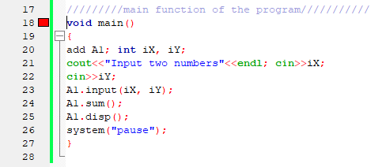

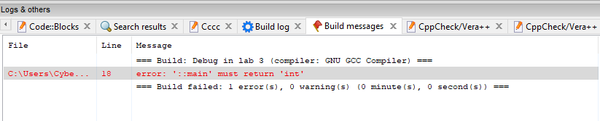

**5.2.** Modify the above task by making the scope of public member functions as private. Create access functions in public scope to access private member functions from main ().

**Program:**

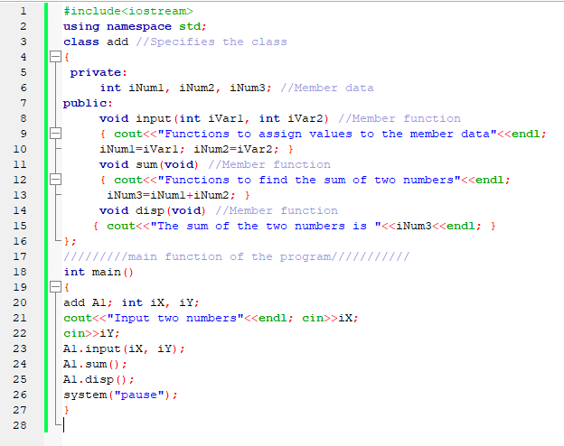

**Output:**

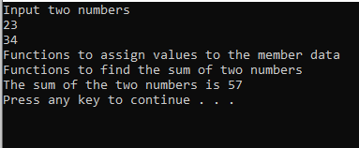

**5.3.** Code the example given above and include a private constructor in the class. Create objects of this class. Test the code and write down how the constructor will be called or unable to be called?

**Program:**

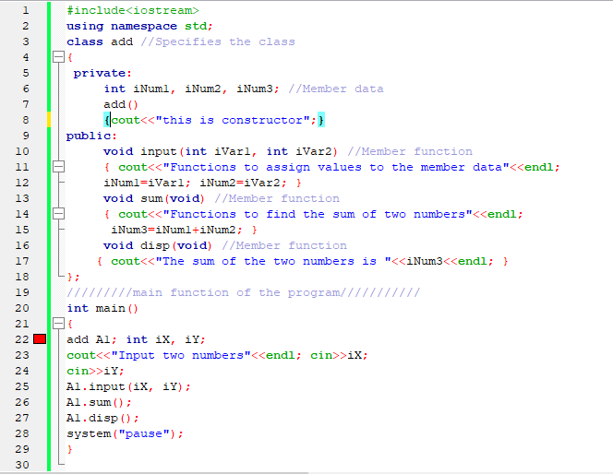

**Output:**

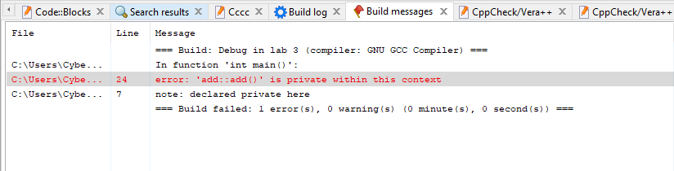

**Home Tasks:**

**6.1.** Create a class of subtraction having two private data members. Create class methods to get data from users and for subtraction of data members. Use appropriate access modifiers for class methods

**Program:**

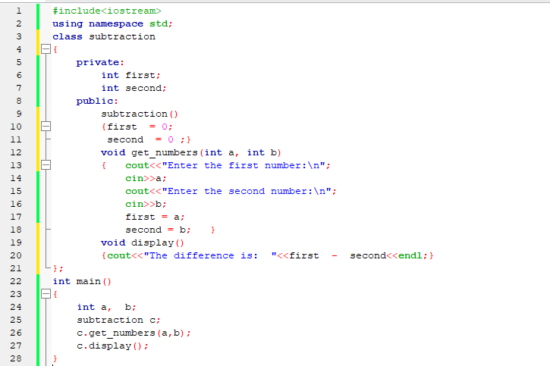

**Output:**

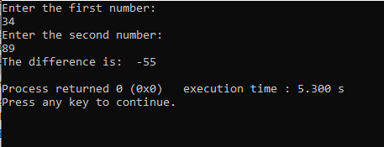

**Critical Analysis:**

In this lab, we learn about the scope of data members and function members. We learn that C++ is sensitive to private and public data members. The data member in private cannot be accessed publicly in any part of program. We frequently practice constructor overloading in each lab.